Design Document

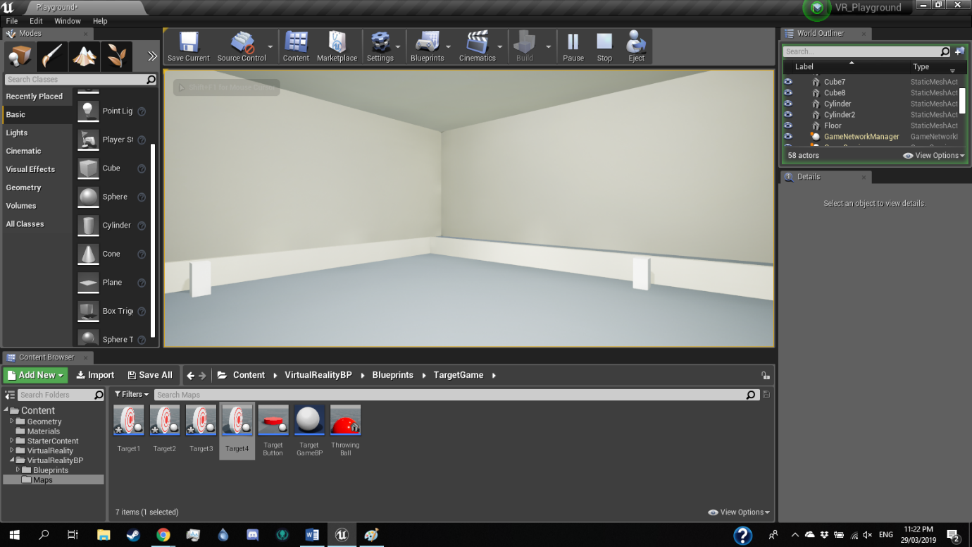Mockup

This is the basic design of the room the game will take place in. The player is placed in a square room, and can access the different minigames at each wall, activated by the pedestals at each barrier.

Interface Design

The main menu will show the prompt to start as soon as the player is ready.

In game, the player is show how much progress they have made towards completion of the game, by how many minigames have been completed.

Interaction Design

The player has the ability to move around the Vive controller to simulate hands, giving them the ability to pick up and throw objects such as the balls during the target shooting game, and pressing buttons to start the games by using the triggers. The player can move their head around while wearing the headset, which will be reflected by the player pawns view in game, allowing them to look around the level. The player can also teleport around the level by holding the thumb button to display the teleportation arc, and releasing to teleport.